LINEAR DISCRIMINANT
ANALYSIS
Complete Trainee Notes with Full Numerical Calculation
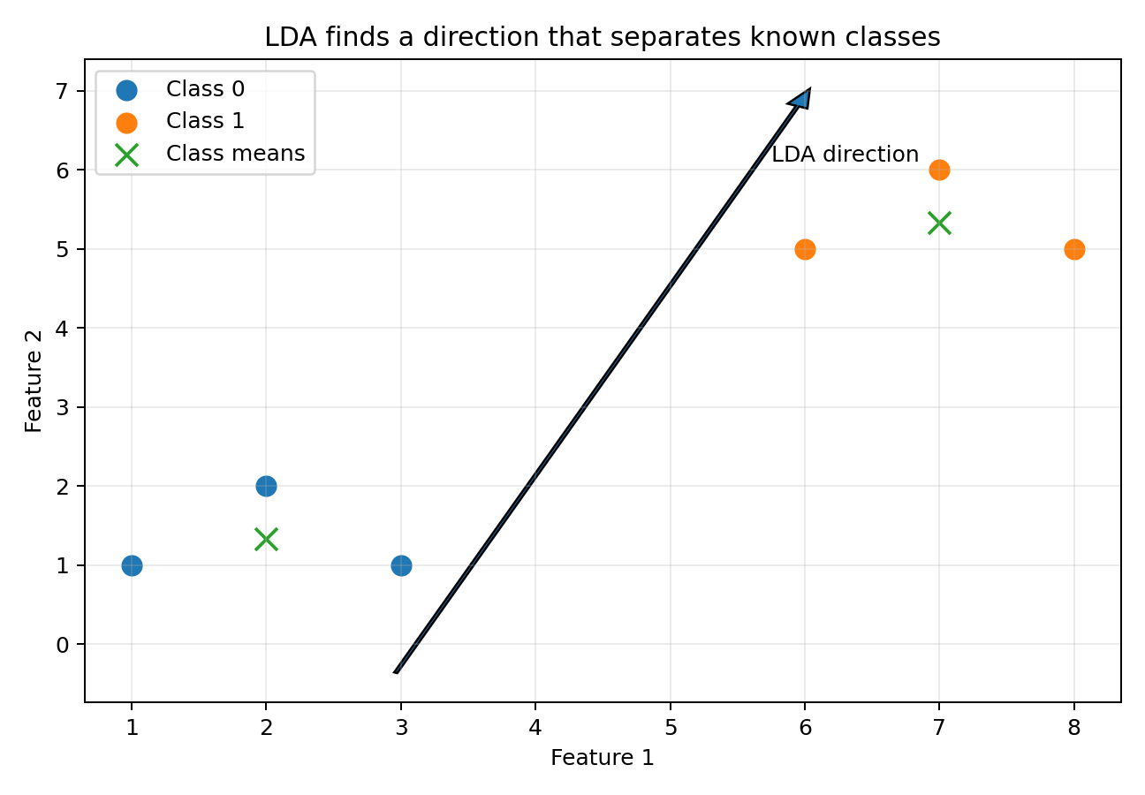
LDA uses class labels to find directions that separate classes while keeping each class compact.
Includes intuition, complete formulas, manual calculation, Python hands-on, FAQs, quiz and answers
Prepared for classroom learning

Contents
1. Dimensionality reduction recap
2. What is Linear Discriminant Analysis?
3. LDA as dimensionality reduction and as a classifier
4. Core intuition: between-class versus within-class scatter
5. Important terminology and notation
6. Data preparation before LDA
7. Complete LDA workflow
8. Full two-class numerical example
9. General LDA formulas
10. Fisher optimization and generalized eigenvalues
11. Eigenvalues, eigenvectors and component selection
12. Multi-class LDA and the K - 1 rule
13. LDA decision rule and decision boundaries
14. Mahalanobis distance versus Euclidean distance
15. Assumptions, limitations and nonlinear cases
16. LDA versus PCA, QDA and Logistic Regression
17. Using PCA and LDA together
18. Singular covariance and regularized LDA
19. Python hands-on: from scratch and scikit-learn
20. Evaluation, common mistakes and good practice
21. FAQs and interview questions
22. Revision quiz with answers
23. Formula sheet and glossary

1. Dimensionality Reduction Recap
A dimension is an input feature or column used by a machine-learning model. A dataset with 100 input columns has 100 dimensions.
Simple example
A student dataset may contain Math, Science, English, attendance, assignments, project score and many other columns. Dimensionality reduction represents these columns using fewer new directions.

Feature selection versus feature extraction
Approach | What it does | Example
Feature selection | Keeps some original columns and drops others. | Keep Math and Science; drop duplicate or irrelevant columns.
Feature extraction | Creates new columns by combining original columns. | LDA creates LD1, LD2 and so on.

LDA is a feature-extraction method because it creates new discriminant components from the original features.

2. What Is Linear Discriminant Analysis?
Definition
Linear Discriminant Analysis (LDA) is a supervised linear method that uses class labels to find directions where different classes are far apart and observations belonging to the same class stay close together.

- Supervised: LDA needs the target labels while learning the directions.
- Linear: each LDA component is a weighted sum of the original features.
- Discriminant: the new directions are chosen for class separation.
- Analysis: the same mathematical model can be used for transformation and classification.
LD1 = w₁x₁ + w₂x₂ + ... + wₚxₚ
The weights decide how much each original feature contributes to the discriminant direction.

A simple analogy
Imagine two groups of students sitting in a room. Looking from the front, the groups may overlap. If you move to another viewing angle, the groups may become clearly separated. LDA searches for that viewing direction using the known group labels.

3. LDA as Dimensionality Reduction and as a Classifier
Use of LDA | What happens | Output
Dimensionality reduction | The data is projected onto LD1, LD2 and other discriminant directions. | New numerical features.
Classification | LDA estimates a score for every class and assigns the class with the highest score. | Predicted class label and probabilities.

Important
In scikit-learn, LinearDiscriminantAnalysis can directly predict classes. It can also transform data into a lower-dimensional discriminant space when the selected solver supports transformation.

4. Core Intuition: Between-Class and Within-Class Scatter
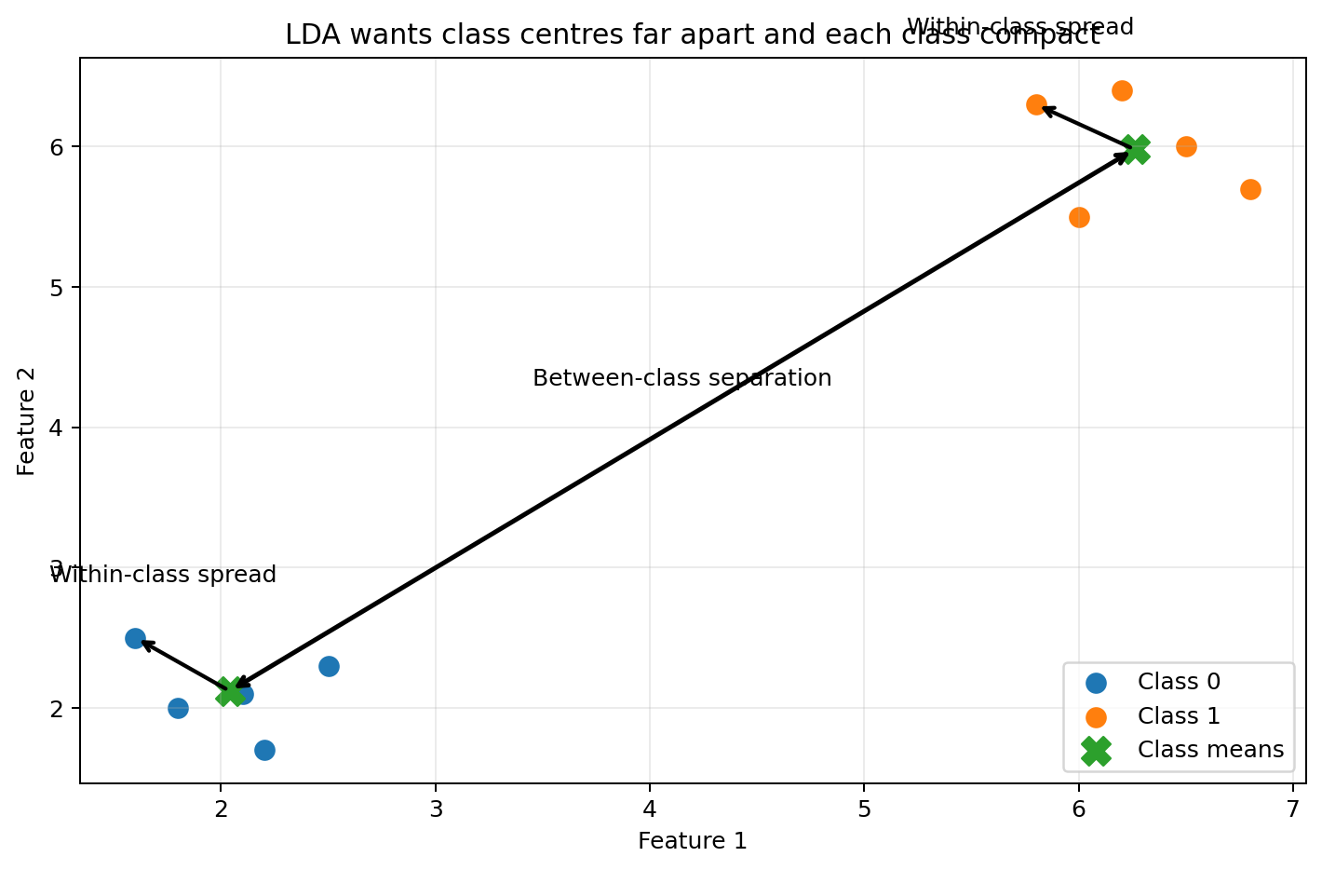
Figure 1. LDA rewards large separation between class centres and penalizes spread inside each class.

Between-class scatter
Between-class scatter measures how far the class means are from the overall mean. Larger separation is desirable.

Within-class scatter
Within-class scatter measures how far observations are from their own class mean. Smaller within-class spread is desirable.
LDA objective = large between-class separation / small within-class spread

Easy memory line
LDA wants different classes far apart and members of the same class close together.

5. Important Terminology and Notation
Symbol | Meaning in simple terms
N | Total number of observations.
p | Number of input features.
K | Number of target classes.
nₖ | Number of observations in class k.
xᵢ | One observation represented as a feature vector.
μₖ | Mean vector, or centre, of class k.
μ | Overall mean vector of all observations.
S_W | Within-class scatter matrix.
S_B | Between-class scatter matrix.
w | One discriminant direction.
W | Matrix containing several discriminant directions.
λ | Eigenvalue measuring the discriminative strength of a direction.

Scatter matrix versus covariance matrix
A scatter matrix uses sums of outer products. A covariance matrix usually divides by a sample-count factor. Different textbooks may use slightly different scaling. The main LDA directions remain the same when the scaling is applied consistently, although the numerical eigenvalues may change.

6. Data Preparation Before LDA
- Select meaningful input features and remove identifiers such as customer ID.
- Handle missing values because standard LDA cannot directly use missing entries.
- Encode categorical inputs appropriately; do not treat arbitrary category codes as natural numerical order.
- Inspect severe outliers because means and covariance can be distorted by extreme observations.
- Split the data into training and test sets before fitting any scaler, LDA transformation or feature selection.
- Fit every preprocessing step only on the training data, then use the fitted step to transform validation and test data.
- Use stratified splitting when possible so class proportions remain similar in training and test sets.

Is standardization compulsory?
Not always. In exact full-covariance LDA, changing feature units through an invertible linear scaling does not fundamentally change the fitted classification rule because the covariance adjusts. However, standardization is often helpful for numerical stability, interpretation, regularization, and downstream models. It is especially sensible when features use very different units.
Leakage warning
Do not standardize or fit LDA on the complete dataset before the train-test split. That allows information from the test set to influence training.

7. Complete LDA Workflow
Step | Action | Purpose
1 | Prepare and split the data. | Keep test data unseen.
2 | Calculate class means and the overall mean. | Locate the class centres.
3 | Build S_W. | Measure spread inside classes.
4 | Build S_B. | Measure separation of class centres.
5 | Solve the generalized eigenvalue problem. | Find discriminant directions.
6 | Sort directions by eigenvalue. | Put the strongest separation first.
7 | Choose up to min(p, K - 1) components. | Reduce dimensionality.
8 | Project data using Z = XW. | Create LD scores.
9 | Train or use the LDA classifier. | Make predictions.
10 | Evaluate on unseen data. | Check whether the method generalizes.

8. Complete Numerical Example: Two-Class LDA by Hand
We have two classes of students, Fail and Pass, and two features: Math and Science marks. The values are deliberately small so every step can be calculated manually.
Student | Class | Math (x₁) | Science (x₂)
F1 | Fail | 2 | 2
F2 | Fail | 3 | 2
F3 | Fail | 2 | 3
P1 | Pass | 7 | 7
P2 | Pass | 8 | 7
P3 | Pass | 7 | 8

Step 1 - Calculate each class mean
μ_Fail = [(2+3+2)/3, (2+2+3)/3] = [2.33, 2.33]

μ_Pass = [(7+8+7)/3, (7+7+8)/3] = [7.33, 7.33]

The difference between the class means is:
μ_Pass - μ_Fail = [5, 5]
The class centres differ equally in Math and Science.

Step 2 - Centre every observation around its own class mean
Observation | Original point | Class mean | Deviation x - μₖ
F1 | [2, 2] | [2.33, 2.33] | [-0.33, -0.33]
F2 | [3, 2] | [2.33, 2.33] | [0.67, -0.33]
F3 | [2, 3] | [2.33, 2.33] | [-0.33, 0.67]
P1 | [7, 7] | [7.33, 7.33] | [-0.33, -0.33]
P2 | [8, 7] | [7.33, 7.33] | [0.67, -0.33]
P3 | [7, 8] | [7.33, 7.33] | [-0.33, 0.67]

Step 3 - Convert each deviation into an outer-product matrix
For a deviation vector d = [a, b]ᵀ, the outer product is:
ddᵀ = [[a², ab], [ab, b²]]
The diagonal contains squared deviations; the off-diagonal contains cross-products.

Example for F1, where d = [-1/3, -1/3]ᵀ:
ddᵀ = [[1/9, 1/9], [1/9, 1/9]]

Why transpose?
Multiplying a deviation column vector by its transpose creates a matrix in which every feature deviation is multiplied with every other feature deviation.

Step 4 - Add the outer products inside each class
S_Fail = [[2/3, -1/3], [-1/3, 2/3]] ≈ [[0.67, -0.33], [-0.33, 0.67]]

S_Pass = [[2/3, -1/3], [-1/3, 2/3]] ≈ [[0.67, -0.33], [-0.33, 0.67]]

Step 5 - Build the total within-class scatter matrix
S_W = S_Fail + S_Pass = [[4/3, -2/3], [-2/3, 4/3]]

S_W ≈ [[1.33, -0.67], [-0.67, 1.33]]
This matrix summarizes spread inside both classes.

Step 6 - Invert the within-class scatter matrix
For a 2 × 2 matrix A = [[a, b], [c, d]]:
A⁻¹ = 1/(ad - bc) × [[d, -b], [-c, a]]

S_W⁻¹ = [[1, 0.5], [0.5, 1]]

Step 7 - Calculate the two-class Fisher direction
w = S_W⁻¹(μ_Pass - μ_Fail)

w = [[1, 0.5], [0.5, 1]] [5, 5]ᵀ = [7.5, 7.5]ᵀ

Only the direction matters. Multiplying or dividing w by a non-zero constant does not change the separating line. Therefore:
w ∝ [1, 1]ᵀ

Normalized direction = [0.7071, 0.7071]ᵀ
Normalization makes the length of w equal to 1.

Step 8 - Project every point onto the LDA direction
Using the simpler proportional direction w = [1, 1], each score is Math + Science:
Observation | Class | Calculation | LD1 score
F1 | Fail | 2 + 2 | 4
F2 | Fail | 3 + 2 | 5
F3 | Fail | 2 + 3 | 5
P1 | Pass | 7 + 7 | 14
P2 | Pass | 8 + 7 | 15
P3 | Pass | 7 + 8 | 15

The projected class means are:
Mean LD1_Fail = (4 + 5 + 5)/3 = 4.67

Mean LD1_Pass = (14 + 15 + 15)/3 = 14.67

Step 9 - Create a simple midpoint threshold
Threshold = (4.67 + 14.67)/2 = 9.67

- LD1 score below 9.67 → predict Fail.
- LD1 score above 9.67 → predict Pass.
Important
This midpoint rule assumes equal class priors and equal error costs. LDA can shift the boundary when one class is more common or one error is more costly.

Step 10 - Calculate S_B and connect it to the eigenvalue problem
Because both classes contain three observations, the overall mean is [4.83, 4.83].
S_B = Σₖ nₖ(μₖ - μ)(μₖ - μ)ᵀ = [[37.5, 37.5], [37.5, 37.5]]

S_W⁻¹S_B = [[56.25, 56.25], [56.25, 56.25]]

The eigenvectors are proportional to [1, 1] and [1, -1]. Their eigenvalues are 112.5 and 0.
- The direction [1, 1] has a large eigenvalue and clearly separates the classes.
- The direction [1, -1] has eigenvalue 0 and adds no class separation because both class means have the same Math-minus-Science value.
J([1,1]) = 112.5
The eigenvalue equals the between-to-within separation ratio for that direction.

9. General LDA Formulas

Class mean
μₖ = (1/nₖ) Σᵢ∈Cₖ xᵢ
Find the centre of class k.

Overall mean
μ = (1/N) Σᵢ₌₁ᴺ xᵢ
Find the centre of the entire dataset.

Within-class scatter matrix
S_W = Σₖ₌₁ᴷ Σᵢ∈Cₖ (xᵢ - μₖ)(xᵢ - μₖ)ᵀ
Measure spread inside the classes.

Between-class scatter matrix
S_B = Σₖ₌₁ᴷ nₖ(μₖ - μ)(μₖ - μ)ᵀ
Measure separation of the class centres.

Total scatter relationship
S_T = S_W + S_B
Total scatter can be decomposed into within-class and between-class scatter.

Projection
z = wᵀx
Project one observation onto one LDA direction.

Z = XW
Project all observations onto several discriminant directions.

10. Fisher Optimization and the Generalized Eigenvalue Problem
For one direction w, the projected between-class scatter is wᵀS_Bw and the projected within-class scatter is wᵀS_Ww.
J(w) = (wᵀS_Bw) / (wᵀS_Ww)
Maximize class separation while minimizing spread inside classes.

The ratio would not change if w were multiplied by a constant. We can therefore impose the constraint wᵀS_Ww = 1 and maximize wᵀS_Bw.
Maximize wᵀS_Bw subject to wᵀS_Ww = 1

Using a Lagrange multiplier λ gives:
S_Bw = λS_Ww
This is a generalized eigenvalue problem.

When S_W is invertible:
S_W⁻¹S_Bw = λw

Interpretation
The eigenvector w gives a discriminant direction. The eigenvalue λ tells us how much between-class separation that direction provides relative to within-class spread.

Multiple discriminant directions
J(W) = trace[(WᵀS_WW)⁻¹(WᵀS_BW)]
One common matrix objective for selecting several discriminant directions.

In practice, we solve the generalized eigenvalue problem and keep the eigenvectors associated with the largest non-zero eigenvalues.

11. Eigenvalues, Eigenvectors and Component Selection
Item | Meaning in LDA
Eigenvector | A direction used to create an LDA component such as LD1 or LD2.
Eigenvalue | The discriminative strength of that direction: separation between classes relative to spread inside classes.
Largest eigenvalue | The best available discriminant direction, called LD1.
Zero eigenvalue | A direction that adds no new separation between class centres.

Unlike PCA, an LDA eigenvalue does not represent ordinary total data variance. It represents discriminative information.
Relative discriminative ratio for LDⱼ = λⱼ / Σᵣ λᵣ

Sign note
An eigenvector and its negative represent the same axis. If software returns [-0.707, -0.707] instead of [0.707, 0.707], the direction is still correct; only the signs of projected scores reverse.

12. Multi-Class LDA and the K - 1 Rule
Maximum LDA components = min(p, K - 1)

More exactly, the number of non-zero useful components is rank(S_B), which cannot exceed min(p, K - 1). Some directions may have zero eigenvalues if class means do not provide independent separation.
Features p | Classes K | Maximum components
10 | 2 | min(10,1) = 1
10 | 3 | min(10,2) = 2
2 | 5 | min(2,4) = 2
100 | 4 | min(100,3) = 3

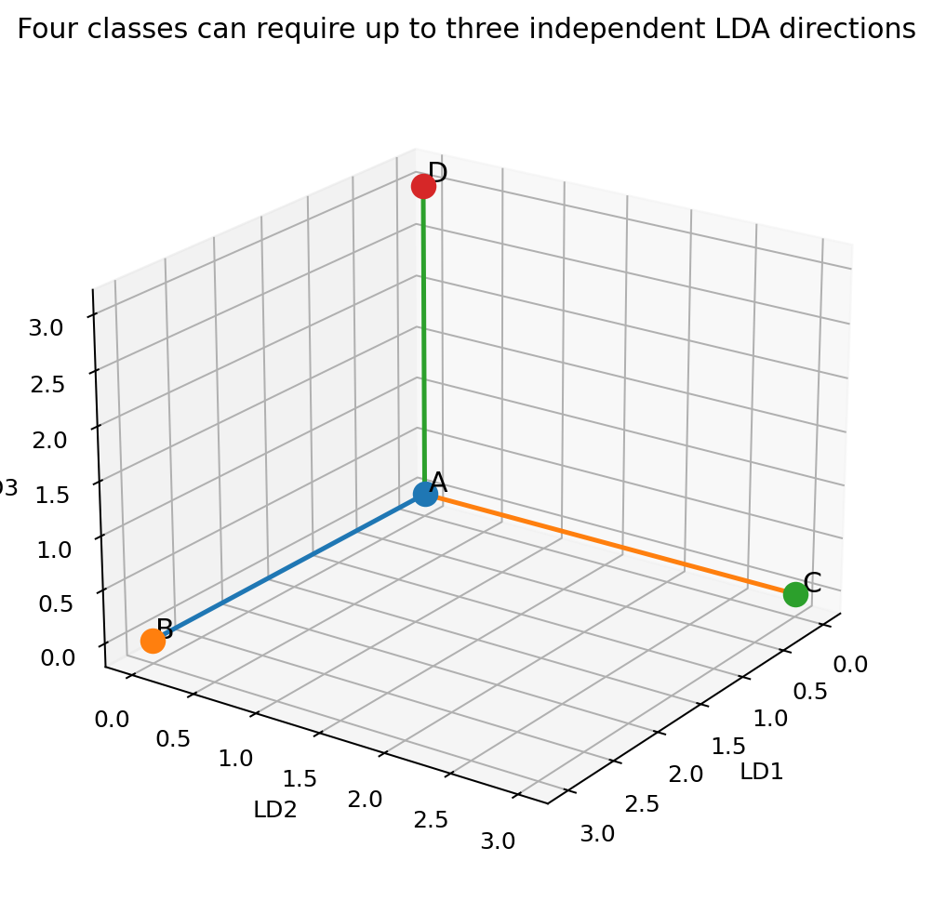
Figure 2. With four classes, LDA can create at most three independent discriminant directions.
A two-dimensional LDA plot may hide separation that exists in LD3. For example, Class A and Class D may overlap in LD1-LD2 but separate when LD3 is included. With four classes, there are no additional standard LDA dimensions beyond the third.

13. LDA Decision Rule and Linear Decision Boundaries
The probabilistic derivation of LDA assumes that every class follows a multivariate normal distribution with its own mean μₖ but the same covariance matrix Σ.
x | y = k ~ N(μₖ, Σ)

For class k, LDA calculates the discriminant score:
δₖ(x) = xᵀΣ⁻¹μₖ - ½μₖᵀΣ⁻¹μₖ + log(πₖ)
πₖ is the prior probability of class k.

The observation is assigned to the class with the largest δₖ(x).

Pairwise boundary between classes k and l
xᵀΣ⁻¹(μₖ-μₗ) - ½(μₖᵀΣ⁻¹μₖ - μₗᵀΣ⁻¹μₗ) + log(πₖ/πₗ) = 0

The equation is linear in x because the same covariance matrix is used for all classes. Therefore, LDA produces straight lines in two dimensions, planes in three dimensions and hyperplanes in higher dimensions.

Role of class priors
- Equal priors: each class starts with equal preference.
- Unequal priors: a more common class receives a larger log(πₖ) term, shifting the boundary.
- Custom priors can be supplied when business knowledge says future class proportions differ from training proportions.

14. Mahalanobis Distance Versus Euclidean Distance
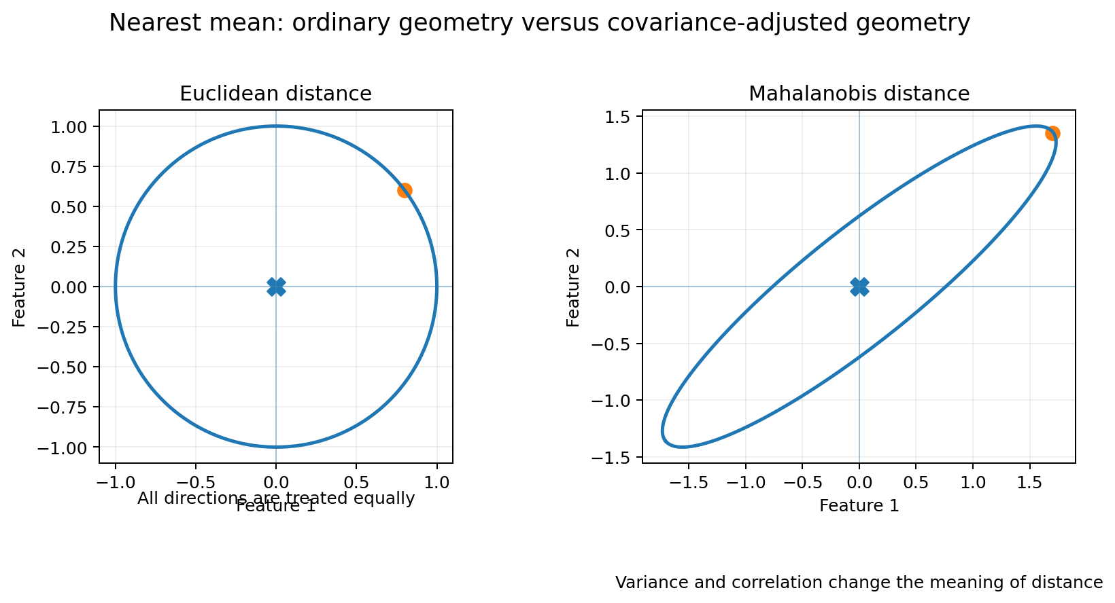
Figure 3. Mahalanobis distance respects the covariance shape; Euclidean distance treats all directions equally.

Euclidean distance
d_E(x, μₖ) = √[(x - μₖ)ᵀ(x - μₖ)]
Ordinary straight-line distance.

Mahalanobis distance
d_M(x, μₖ) = √[(x - μₖ)ᵀΣ⁻¹(x - μₖ)]
Distance adjusted for feature variance and correlation.

Euclidean distance | Mahalanobis distance
Ignores feature correlation. | Uses the covariance matrix to account for correlation.
Treats every direction equally. | Treats movement along low-variance directions as more unusual.
Sensitive to units and scale. | Adjusts for variance and scale through Σ⁻¹.
Equal-distance contours are circles or spheres. | Equal-distance contours can be ellipses or ellipsoids.

When is LDA exactly nearest Mahalanobis mean?
With a shared invertible covariance matrix, equal class priors and equal misclassification costs, maximizing the LDA score is identical to assigning each point to the closest class mean using Mahalanobis distance.
Choose class k that minimizes d_M²(x, μₖ)

What changes with unequal priors?
Choose class k that minimizes d_M²(x, μₖ) - 2log(πₖ)

When does it become ordinary nearest-centroid classification?
Σ = σ²I

This means all features have equal variance, features are uncorrelated and every class shares the same spherical covariance. Mahalanobis distance then becomes a constant multiple of Euclidean distance, so the nearest class mean is selected using ordinary straight-line distance.
Shared covariance structure | Equivalent geometry
General positive-definite Σ | Mahalanobis distance.
Diagonal Σ with unequal variances | Variance-standardized Euclidean distance.
Σ = σ²I | Ordinary Euclidean nearest-centroid distance.

Whitening interpretation
z = Σ⁻¹ᐟ²x

After whitening, the shared covariance becomes the identity matrix. Mahalanobis distance in the original space becomes ordinary Euclidean distance in the whitened space.

15. Assumptions, Limitations and Nonlinear Cases

Main LDA assumptions
- The target is categorical and class labels are available.
- Observations are reasonably independent.
- Within each class, the feature distribution is approximately multivariate normal for the classical probabilistic interpretation.
- Classes share approximately the same covariance matrix, also called homoscedasticity.
- The class means and shared covariance can be estimated reliably from the available data.
- The relationship can be represented sufficiently well using linear boundaries.
LDA may still work when normality is imperfect, but performance should be validated rather than assumed.

What happens when covariance differs strongly by class?
LDA uses one pooled covariance matrix, so it creates a compromise straight boundary. Quadratic Discriminant Analysis (QDA) allows every class to have its own covariance and can create curved boundaries, but it estimates more parameters and usually needs more data.

What happens with concentric circles or moons?
LDA is linear and class means may even be identical in concentric-circle data. It cannot create the required curved boundary. RBF SVM, trees, K-nearest neighbours, engineered radius features or nonlinear discriminant methods may be more suitable.

Other limitations
- Sensitive to severe outliers because means and covariance are affected.
- Can become unstable when features greatly outnumber observations.
- Creates combinations that may be harder to explain than original features.
- A 2D LDA plot can hide separation present in later allowed dimensions.
- Imbalanced classes and unequal error costs require careful choice of priors, thresholds and metrics.

16. LDA Versus PCA, QDA and Logistic Regression

LDA versus PCA
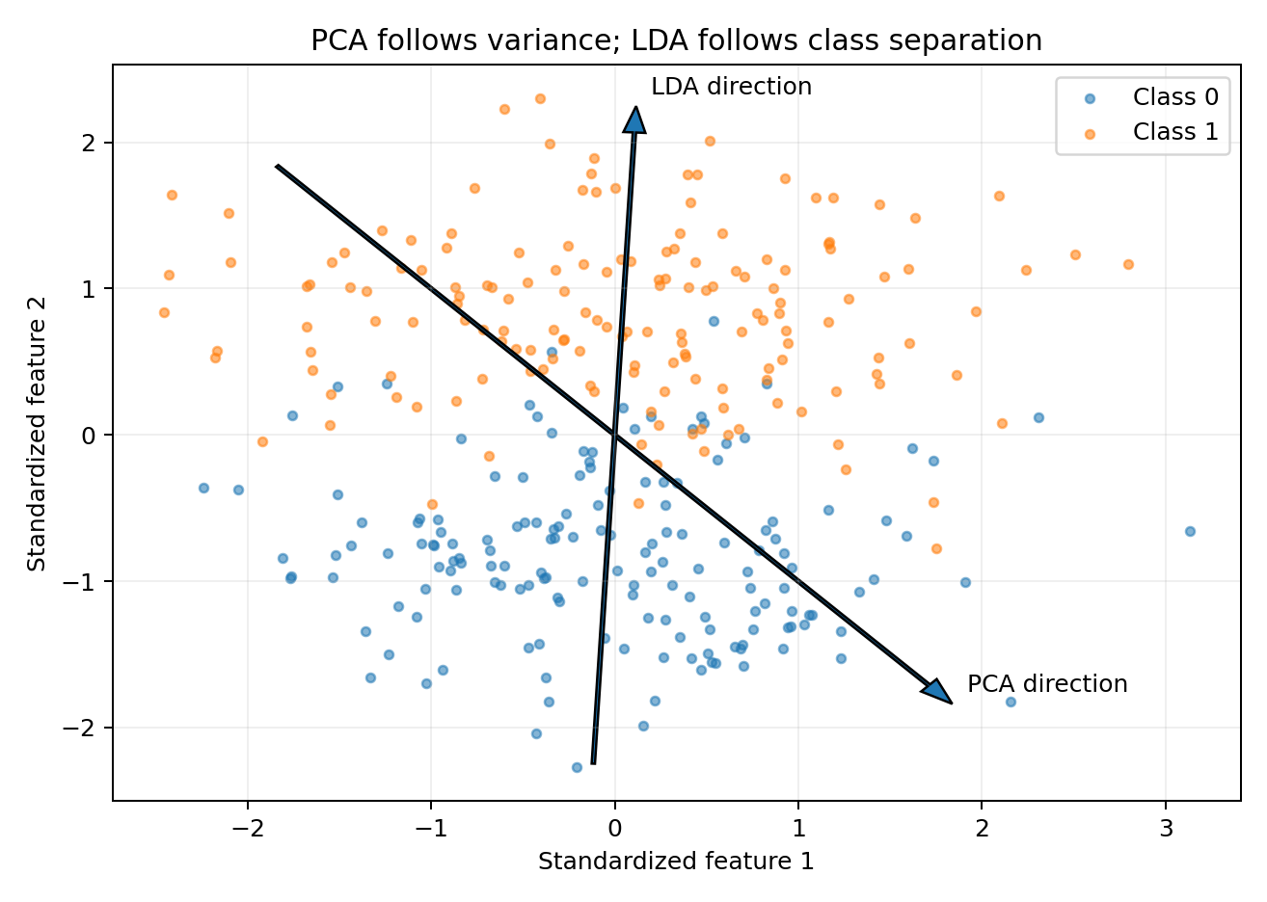
Figure 4. PCA follows overall variance; LDA uses labels to search for class separation.
Question | PCA | LDA
Uses target labels? | No. | Yes.
Primary goal | Preserve overall variance. | Maximize class separation.
Maximum components | min(p, N - 1). | min(p, K - 1).
Best use | Unlabelled compression and visualization. | Classification-focused reduction.
Can discard class signal? | Yes, because low-variance directions may be predictive. | Less likely for linear mean separation because labels guide the directions.

LDA versus QDA
LDA | QDA
One shared covariance matrix. | A separate covariance matrix for each class.
Linear decision boundaries. | Quadratic or curved decision boundaries.
Fewer parameters; works with less data. | More flexible but needs more data and can overfit.
Use when covariance shapes are similar. | Use when covariance shapes differ meaningfully.

LDA versus Logistic Regression
LDA | Logistic Regression
Generative: models class distributions and uses Bayes rule. | Discriminative: directly models class probabilities or log-odds.
Assumes shared covariance and approximate Gaussian classes. | Does not require Gaussian feature distributions.
Can work well with small samples when assumptions are reasonable. | Often more robust when distribution assumptions are poor.
Provides a supervised dimensionality-reduction transform. | Normally provides a boundary, not an LDA-style feature transform.

Method choice
Use validation performance, class-level metrics and business costs. The mathematically more flexible method is not automatically the best method.

17. Using PCA and LDA Together
Standardization → PCA → LDA or classifier

PCA before LDA can help when there are hundreds or thousands of correlated features, when the within-class covariance is unstable, or when noise needs to be reduced.
- PCA first compresses the feature space without labels.
- LDA then uses labels to find class-separating directions in the retained PCA space.
Main risk
PCA may discard a low-variance direction that is highly useful for separating classes. Once discarded, LDA cannot recover it. Compare direct LDA with PCA-plus-LDA using cross-validation.

Do not automatically reduce the data to only two PCA components before LDA. Two components are useful for a graph, but may remove important predictive information.

18. Singular Covariance and Regularized LDA
S_W may be singular or poorly conditioned when features are highly correlated, duplicate information exists, or the number of features is large compared with the number of training observations.
rank(S_W) ≤ N - K

A full inverse cannot exist when the rank is smaller than p. Practical solutions include:
- Remove constant, duplicate or nearly duplicate features.
- Collect more observations.
- Use PCA before LDA, fitted only on training data.
- Use shrinkage or regularized covariance estimation.
- Use an SVD-based implementation that avoids explicitly inverting S_W.
- Use a pseudoinverse carefully, while validating stability.

What shrinkage does
Σ_shrunk = (1 - α)Σ_sample + αT
T is a stable target, often related to a scaled identity matrix.

Shrinkage moves an unstable sample covariance toward a simpler, more stable covariance. It can improve generalization when the sample size is small relative to the number of features.

19. Python Hands-On

A. Two-class LDA from scratch with NumPy
import numpy as np
fail = np.array([[2, 2], [3, 2], [2, 3]], dtype=float)
passed = np.array([[7, 7], [8, 7], [7, 8]], dtype=float)
mu_fail = fail.mean(axis=0)
mu_pass = passed.mean(axis=0)
# Build within-class scatter
S_w = np.zeros((2, 2))
for class_data, class_mean in [(fail, mu_fail), (passed, mu_pass)]:
for x in class_data:
d = (x - class_mean).reshape(-1, 1)
S_w += d @ d.T
# Solve S_w w = (mu_pass - mu_fail)
# solve() is numerically preferable to explicitly calculating an inverse.
w = np.linalg.solve(S_w, mu_pass - mu_fail)
w_unit = w / np.linalg.norm(w)
scores_fail = fail @ w_unit
scores_pass = passed @ w_unit
threshold = (scores_fail.mean() + scores_pass.mean()) / 2
print("Fail mean:", mu_fail)
print("Pass mean:", mu_pass)
print("Within-class scatter:\n", S_w)
print("Direction w:", w)
print("Normalized direction:", w_unit)
print("Fail scores:", scores_fail)
print("Pass scores:", scores_pass)
print("Midpoint threshold:", threshold)

Expected pattern: the direction is proportional to [1, 1]. The sign may be reversed depending on the implementation; the separating axis remains equivalent.

B. Generalized eigenvalue calculation from scratch
# Overall mean and between-class scatter
X = np.vstack([fail, passed])
mu = X.mean(axis=0)
S_b = (
len(fail) * np.outer(mu_fail - mu, mu_fail - mu)
+ len(passed) * np.outer(mu_pass - mu, mu_pass - mu)
)
# Educational calculation; for production, avoid an explicit inverse.
M = np.linalg.inv(S_w) @ S_b
eigenvalues, eigenvectors = np.linalg.eig(M)
order = np.argsort(eigenvalues)[::-1]
eigenvalues = eigenvalues[order]
eigenvectors = eigenvectors[:, order]
print("Between-class scatter:\n", S_b)
print("Eigenvalues:", eigenvalues)
print("Eigenvectors:\n", eigenvectors)

The first eigenvalue should be approximately 112.5 and the second approximately 0. The first eigenvector is proportional to [1, 1].

C. Safe LDA transformer and classifier on the Digits dataset
import numpy as np
from sklearn.datasets import load_digits
from sklearn.model_selection import train_test_split
from sklearn.preprocessing import StandardScaler
from sklearn.discriminant_analysis import LinearDiscriminantAnalysis
from sklearn.linear_model import LogisticRegression
from sklearn.pipeline import Pipeline
from sklearn.metrics import accuracy_score, classification_report, confusion_matrix
X, y = load_digits(return_X_y=True)
X_train, X_test, y_train, y_test = train_test_split(
X, y,
test_size=0.20,
random_state=42,
stratify=y
)
# Digits has 10 classes, so at most 9 LDA components are possible.
transform_then_model = Pipeline([
("scaler", StandardScaler()),
("lda", LinearDiscriminantAnalysis(n_components=9)),
("model", LogisticRegression(max_iter=3000))
])
transform_then_model.fit(X_train, y_train)
y_pred = transform_then_model.predict(X_test)
print("Accuracy:", accuracy_score(y_test, y_pred))
print("Confusion matrix:\n", confusion_matrix(y_test, y_pred))
print(classification_report(y_test, y_pred))

D. Use LDA directly as the classifier
lda_classifier = Pipeline([
("scaler", StandardScaler()),
("lda", LinearDiscriminantAnalysis())
])
lda_classifier.fit(X_train, y_train)
y_pred_lda = lda_classifier.predict(X_test)
y_prob_lda = lda_classifier.predict_proba(X_test)
print("LDA accuracy:", accuracy_score(y_test, y_pred_lda))
print("Probability shape:", y_prob_lda.shape)

E. Shrinkage LDA when covariance estimation is unstable
shrinkage_lda = Pipeline([
("scaler", StandardScaler()),
("lda", LinearDiscriminantAnalysis(
solver="lsqr",
shrinkage="auto"
))
])
shrinkage_lda.fit(X_train, y_train)
y_pred_shrink = shrinkage_lda.predict(X_test)
print("Shrinkage LDA accuracy:", accuracy_score(y_test, y_pred_shrink))

The lsqr shrinkage configuration is used for classification rather than dimensionality transformation. For shrinkage with a transformable eigen-based solution, an eigen solver can be explored and validated.

F. Two-dimensional LDA visualization
import matplotlib.pyplot as plt
# For an unbiased model evaluation, fit on training data only.
# This full-data fit is shown only for a classroom visualization.
X_scaled = StandardScaler().fit_transform(X)
X_lda_2d = LinearDiscriminantAnalysis(n_components=2).fit_transform(X_scaled, y)
plt.figure(figsize=(8, 6))
plt.scatter(X_lda_2d[:, 0], X_lda_2d[:, 1], c=y, s=12)
plt.xlabel("LD1")
plt.ylabel("LD2")
plt.title("Digits in two-dimensional LDA space")
plt.show()

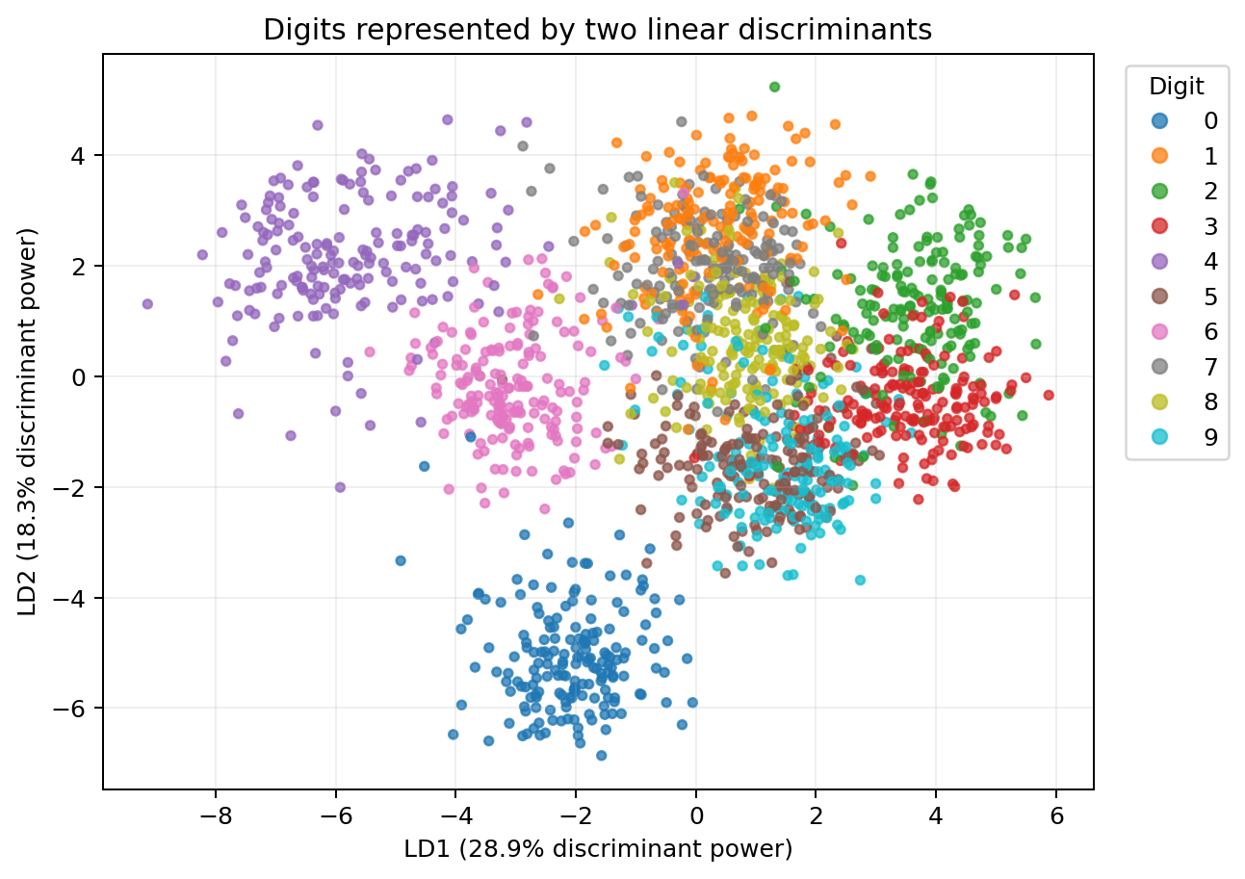
Figure 5. A two-dimensional LDA view of the Digits dataset. Some classes may still overlap.
Interpretation note
The scikit-learn attribute explained_variance_ratio_ for LDA refers to relative discriminative information across the selected directions. It is not the same as total variance explained by PCA.

20. Evaluation, Common Mistakes and Good Practice

Evaluation metrics
Metric | Question it answers
Accuracy | What fraction of all predictions were correct?
Precision | Out of observations predicted as a class, how many truly belonged to it?
Recall | Out of observations truly belonging to a class, how many were found?
F1-score | What is the balance between precision and recall?
Confusion matrix | Which classes are being confused with each other?
Cross-validation | Does performance remain stable across different training-validation splits?

Common mistakes
- Fitting the scaler or LDA on the complete dataset before splitting.
- Using LDA when there is no categorical target.
- Asking for more than min(p, K - 1) components.
- Assuming a visually attractive 2D projection guarantees good test performance.
- Confusing LDA explained-variance ratios with PCA variance explained.
- Ignoring class imbalance and reporting only accuracy.
- Explicitly inverting a nearly singular S_W when a stable solver or regularization is available.
- Assuming standard LDA can solve strongly curved class structures.
- Confusing Linear Discriminant Analysis with Latent Dirichlet Allocation.

Recommended model-development order
1. Split data.
2. Fit imputation and scaling on training data.
3. Fit LDA on training data using labels.
4. Transform training and test data with the fitted LDA when using LDA as a transformer.
5. Train the downstream classifier.
6. Evaluate once on untouched test data.
7. Use cross-validation and pipelines for model comparison and tuning.

21. Frequently Asked Questions
Is LDA supervised?
Yes. It uses the target labels to learn class-separating directions.
Can LDA be used without a target column?
No. Use PCA or another unsupervised method when class labels are unavailable.
Is LDA only dimensionality reduction?
No. It can create transformed features and can also directly classify observations.
Why can two classes produce only one component?
There is only one independent direction between two class means, so K - 1 equals 1.
Why do four classes produce at most three components?
Four class centres can have only three independent relative-separation directions.
Can classes overlap in a 2D LDA plot but separate in 3D?
Yes. Their difference may lie mainly in LD3, which is hidden in the LD1-LD2 plot.
Do LDA weights add to one?
No. A direction is often normalized so the squares of its coefficients sum to one, but the coefficients themselves need not add to one.
What does a negative LDA weight mean?
Increasing that feature moves the projected score in the negative direction, relative to the chosen sign convention.
Can the sign of an LDA component reverse?
Yes. An axis and its negative are equivalent.
Why does LDA use S_W inverse?
It downweights directions with large within-class noise and upweights directions with cleaner separation.
What does an LDA eigenvalue mean?
It measures separation between classes relative to spread within classes for its eigenvector.
Does LDA require perfectly normal data?
No, but the classical probability model assumes approximate class-wise normality. Validate performance when the assumption is weak.
What if covariance differs across classes?
Consider QDA or another model; LDA may produce an oversimplified pooled boundary.
What if S_W is singular?
Use regularization, shrinkage, SVD, feature reduction, PCA-before-LDA or more data.
Is scaling always required?
Not mathematically in every full-covariance case, but it often improves numerical stability and pipeline consistency.
Can PCA be used before LDA?
Yes, especially in high-dimensional data, but select PCA components through cross-validation because PCA may discard class information.
Can LDA solve concentric circles?
Usually not because the required boundary is nonlinear and the class means may be nearly identical.
What is the difference between Linear Discriminant Analysis and Latent Dirichlet Allocation?
They are unrelated methods. Linear Discriminant Analysis is used for classification and supervised reduction; Latent Dirichlet Allocation is a probabilistic topic model for text.

Interview Questions with Concise Answers
Question | Suggested answer
Explain LDA in one sentence. | LDA finds linear combinations of features that maximize class separation relative to within-class spread.
What matrices are used in Fisher LDA? | The between-class scatter matrix S_B and within-class scatter matrix S_W.
What is the optimization objective? | Maximize J(w) = (wᵀS_Bw)/(wᵀS_Ww).
How does the optimization become an eigenvalue problem? | The constrained problem leads to S_Bw = λS_Ww, or S_W⁻¹S_Bw = λw when S_W is invertible.
What do the eigenvectors represent? | The discriminant directions LD1, LD2 and so on.
What do the eigenvalues represent? | The strength of class separation relative to within-class scatter along each direction.
Why is the maximum number of components K - 1? | S_B has rank at most K - 1 because only relative differences among K class means matter.
When is LDA equivalent to nearest Mahalanobis mean? | With shared covariance, equal priors and equal error costs.
When does LDA reduce to Euclidean nearest centroid? | When the shared covariance is σ²I and priors are equal.
Why is the LDA boundary linear? | The shared covariance causes the quadratic xᵀΣ⁻¹x term to cancel between classes.
LDA versus QDA? | LDA shares covariance and gives linear boundaries; QDA uses class-specific covariance and gives quadratic boundaries.
What is shrinkage LDA? | It regularizes covariance toward a stable target to improve estimation in high-dimensional or small-sample data.
How do you avoid data leakage? | Fit scaling and LDA inside a pipeline using training folds only.
Can LDA be used with imbalanced data? | Yes, but priors, thresholds, recall, F1 and class-specific costs must be considered.
What if p is greater than n? | The covariance may be singular; use shrinkage, SVD, feature reduction or PCA-before-LDA and validate carefully.

22. Revision Quiz
# | Question
1 | LDA is supervised. True or false?
2 | What does S_W measure?
3 | What does S_B measure?
4 | Write the Fisher ratio for one direction.
5 | What does the largest eigenvalue indicate?
6 | Maximum LDA components for 8 features and 3 classes?
7 | Maximum LDA components for 2 features and 5 classes?
8 | Why can two classes have only one LDA component?
9 | Does LDA always require standardization?
10 | When is LDA equivalent to nearest Mahalanobis mean?
11 | When does Mahalanobis distance become proportional to Euclidean distance?
12 | Why does LDA create a linear boundary?
13 | What model may help when class covariances differ strongly?
14 | Why may PCA before LDA be risky?
15 | What is wrong with fitting LDA before the train-test split?
16 | Can LD1 and LD2 hide separation present in LD3?
17 | What does shrinkage improve?
18 | Can LDA directly predict classes in scikit-learn?
19 | Is Linear Discriminant Analysis the same as Latent Dirichlet Allocation?
20 | What is the one-line memory statement for LDA?

Quiz Answers
# | Answer
1 | True.
2 | Spread of observations around their own class means.
3 | Separation of class means around the overall mean.
4 | J(w) = (wᵀS_Bw)/(wᵀS_Ww).
5 | The strongest available class-separating direction.
6 | min(8, 3 - 1) = 2.
7 | min(2, 5 - 1) = 2.
8 | Two class means have only one independent difference direction.
9 | No. It is not strictly required in every exact full-covariance case, but is often useful.
10 | Shared covariance, equal priors and equal error costs.
11 | When Σ = σ²I.
12 | With shared covariance, quadratic terms cancel between class scores.
13 | QDA, or another flexible classifier.
14 | PCA ignores labels and may discard low-variance class-separating information.
15 | It causes data leakage because test information influences the learned transformation.
16 | Yes.
17 | Stability of covariance estimation in small-sample or high-dimensional settings.
18 | Yes.
19 | No.
20 | Find directions with large between-class separation and small within-class spread.

23. Formula Sheet and Glossary

Formula sheet
Concept | Formula
Class mean | μₖ = (1/nₖ)Σᵢ∈Cₖxᵢ
Overall mean | μ = (1/N)Σᵢxᵢ
Within scatter | S_W = ΣₖΣᵢ∈Cₖ(xᵢ-μₖ)(xᵢ-μₖ)ᵀ
Between scatter | S_B = Σₖnₖ(μₖ-μ)(μₖ-μ)ᵀ
Fisher ratio | J(w) = (wᵀS_Bw)/(wᵀS_Ww)
Generalized eigenproblem | S_Bw = λS_Ww
Ordinary eigenproblem | S_W⁻¹S_Bw = λw
Two-class direction | w ∝ S_W⁻¹(μ₁-μ₀)
Projection | z = wᵀx; Z = XW
Maximum components | min(p, K - 1)
LDA class score | δₖ(x)=xᵀΣ⁻¹μₖ-½μₖᵀΣ⁻¹μₖ+logπₖ
Mahalanobis distance | d_M²=(x-μₖ)ᵀΣ⁻¹(x-μₖ)
Euclidean special case | Σ=σ²I
Total scatter | S_T = S_W + S_B

Glossary
Term | Simple meaning
Class | A target category, such as Pass or Fail.
Class mean | The centre of observations belonging to one class.
Overall mean | The centre of all observations.
Scatter | A matrix summary of spread and feature co-movement.
Within-class scatter | Variation of points around their own class means.
Between-class scatter | Variation of class means around the overall mean.
Discriminant direction | A weighted feature combination chosen to separate classes.
LD score | The coordinate of an observation after projection onto an LDA direction.
Prior probability | The expected probability of each class before seeing the features.
Covariance | How two features vary together.
Shared covariance | One pooled covariance matrix used for all classes.
Mahalanobis distance | Distance adjusted for variance and feature correlation.
Eigenvector | A direction that remains on the same axis after a linear transformation.
Eigenvalue | The amount of discriminative separation associated with an eigenvector.
Generalized eigenproblem | An eigenproblem involving two matrices, here S_B and S_W.
Rank | Number of independent directions represented by a matrix.
Singular matrix | A matrix without a normal inverse.
Shrinkage | Regularization that moves an unstable covariance estimate toward a stable target.
Homoscedasticity | The assumption that classes have the same covariance structure.
Data leakage | Test or validation information accidentally influencing model fitting.

Final memory line
LDA uses labels to create up to K - 1 directions that maximize separation between class centres relative to the spread inside each class.

End of Trainee Notes

